10/29/2026
Matt Baker, Sam Davies, Olivia Hey, Dave Sushames
Byte harbor butchers
AI-Enhanced vs Legacy DFIR Tools – A Comparative Efficacy Analysis
Results, Findings, and Recommendations
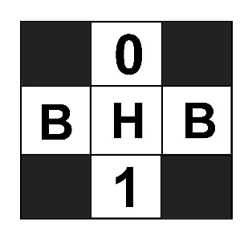


Executive Summary
This research report consolidates the findings, recommendations, and data supporting resolution to the questions: “Do LLMs belong in Digital Forensics and Incident Response (DFIR)?”, “How do DFIR reports generated by LLMs compare to those generated by a human analyst?” and “What are the challenges with augmenting DFIR analysis locally with LLMs?”. This report also includes guidance for future research in this area. LLMs are identified to provide advantages in report generation time, but their findings are often forced and unreliable, requiring validation by an expert which negates the benefits of the LLM. This report also identifies the use cases of LLMs in DFIR and the contextual requirements that cause the LLMs application to Digital Forensics (DF) and Incident Response (IR) investigations to differ in usefulness or efficacy in the real world.

Table of Contents
Executive Summary 1
Report Comparisons and Qualitative Assessment 4
Foremost 4
Nmap 5
Wireshark 5
Tools/Methodology 6
Traditional DFIR Tools 6
Case Files 6
Scripts 6
LLM Models 7
Hardware/OS 8
Design Science Research 8
Findings 9
Context Problem 9
Input Data 10
Foremost 10
Nmap 11
Wireshark 11
Generation Period 12
Corrupted Input Data 15
Thinking Enabled vs Disabled 16
Performance 19
Power 19
Temperature (Physical) 21
Memory 22
Accountability/Traceability 22
Non-comprehensive indications 22
Conclusion 24
Recommendations 25
Input Data 25
XML 25
CSV 25
Configuration 25
For Future Research 26
Data Collection / Analysis and Visualization 26
References 27
Appendices 28
Appendix A – Script Performance Data 28
Appendix B – LLM-Script Generation Time 29

Report Comparisons and Qualitative Assessment

Foremost
Feature | Definition
Tool details | Name and version of the tool.
Intro/Summary | Readable overview for a non-technical audience.
Evidence information | Name and size of the original image.
File count and types | Total number of files, and how many per type of file.
Per-file details | Name and size of each file.
Describes recovered files | What each file actually contains.
Notable findings | Clustering, large files, anything unusual or suspicious.
Limitations | Mentions shortcomings, e.g. corrupted files, fragmentation, lack of access to other tools.

 | Three.dd |  | Eight.dd |  | Nine.dd
Feature | Human | LLM | Human | LLM | Human | LLM
Tool details | Partial | Yes | Partial | Yes | Partial | Yes
Intro/Summary | Yes | Yes | Partial | Yes | Yes | Yes
Evidence information | Partial | Yes | Partial | Yes | Partial | Yes
File count and types | Yes | Yes | Yes | Yes | Yes | Yes
Per-file details | Yes | Yes | Partial | No | Partial | No
Describes recovered files | Yes | No | Yes | No | Yes | No
Notable findings | Yes | Yes | Partial | Yes | No | Yes
Limitations | Yes | Partial | Partial | No | Partial | No
LLM is very good at the tool/evidence information, while humans are not as consistent. Suggests humans don’t read the information that is obvious in the audit.txt file.
Humans are much better at depth, describing the file names and contents each time, although not mentioning the file sizes every time. The LLM only mentioned the per-file details once, which is odd because it’s the same script each time.
Human scores are inconsistent, likely due to difference in personal style, as each report was written by a different team member.

Nmap
Feature | Definition
Tool details | Name and version of the tool.
Intro/Summary | Readable overview for a non-technical audience.
Target information | Host/IP range scanned.
Host status | Whether each host was up.
Open ports | Port numbers, protocols, and states (open/closed/filtered)
Service details | Service names and versions on each port
OS Detection | Operating System guess for each host
Notable findings | Risky or outdated services, unusual ports, anything suspicious.
Limitations | Mentions shortcomings, e.g. filtered ports, guesses, scan scope.

 | 28SepServiceScan |  | SOITscan |  | Nmap_example
Feature | Human | LLM | Human | LLM | Human | LLM
Tool details | Yes | Partial | Partial | Partial | Partial | Partial
Intro/Summary | Yes | Yes | Yes | Yes | Yes | Yes
Target information | Yes | Yes | Partial | Partial | Partial | Yes
Host status | Yes | Yes | Yes | Partial | Partial | Partial
Open ports | Yes | Partial | Partial | Partial | Partial | Partial
Service details | Yes | Partial | Partial | Partial | No | Partial
OS Detection | Partial | Partial | No | Partial | No | Partial
Notable findings | Yes | Yes | Yes | Yes | Partial | Yes
Limitations | Partial | No | No | No | Yes | No

28sepServiceScan:
The LLM-generated report presents Metasploitable host as host .22, the human says it is .21.
.20/.21 have all parts closed, while human says .20 is filtered and .21 is Metasploitable.
.10 is given a “moderate” risk by the LLM in findings, but “low” risk in the summary table. The reason for this is visible in Thinking Enabled vs Disabled on page 16.

Wireshark
Feature | Definition
Tool details | Name and version of the tool.
Intro/Summary | Readable overview for a non-technical audience.
Capture information | File name, capture date/duration, packet count.
Hosts/Conversations | Which IPs/hosts are communicating, and the main conversations.
Timeline | Key activity in the order it happened.
Extracted data | Credentials, files, or cleartext content recovered from the traffic.
Notable findings | Suspicious traffic, insecure protocols, anything unusual.

 | Evidence01.pcap |  | Evidence02.pcap |  | Evidence03.pcap
Feature | Human | LLM | Human | LLM | Human | LLM
Tool details | Partial | No | Partial | No | Yes | No
Intro/Summary | Yes | Yes | Yes | Yes | Yes | Yes
Capture information | Partial | Partial | Partial | Partial | Yes | Partial
Hosts/Conversations | Yes | Yes | Yes | Yes | Partial | Yes
Timeline | Partial | No | No | Partial | Yes | No
Extracted data | Yes | Yes | N/A | Partial | Yes | Partial
Notable findings | Yes | Partial | Yes | Yes | Yes | Partial

Tools/Methodology

Traditional DFIR Tools
These are the 3 tools that were selected to augment with LLMs
Tool | Purpose
Wireshark | Packet capture, packet analysis, network forensics.
Nmap | Network reconnaissance, network triage.
Foremost | File carving.

Case Files
 | Foremost | Nmap | Wireshark
File Type | .DD/.TXT | .XML/.TXT | .PCAP/NG
Converted to | .TXT | .TOON | .CSV
Case File 1 | Three.dd | Nmap_example.xml | evidence01.pcap
Case File 2 | EIGHT.dd | SOITnetworkscan.xml | evidence02.pcapng
Case File 3 | NINE.dd | 28sepServiceScan.xml | evidence03.pcap

Scripts
The team developed scripts to automate the tasks of processing input data, chunking the data, running sequential prompts, generating pdfs with “Pandoc”, recording token usage, and deleting residual files. These scripts were developed in the python language in order to augment every traditional DFIR tool with an LLM. Other experimental models with greater theoretical capacity were created, but do not appear in the raw data found in this report. This distinction is important because some findings irrelevant to performance/metrics were gathered with these tools.
Script | Input Data Type | Context | Prompts | Thinking | Appears in Data
NinemostV1.py | Foremost | 32k | 1 | No | Yes
SilentCartograhperV1.py | Nmap | 32k | 3 | No | Yes
HammerheadV1.py | Wireshark | 32k | 3 | No | Yes
SilentCartographerV3.py | Nmap | 64k | 5 | Yes | No
HammerheadV3.py | Wireshark | 64k | 5 | Yes | No

LLM Models
The team made two custom builds based on the Gemma4:26b model specifically for this research. Gemma4:26b is a well-regarded model for local implementation. The team tested multiple other models such as Qwen, Mistral, and Nemotron. The quickest, most lucid, least erroneous results were produced by Gemma4:26b. This can be attributed to the 26 billion parameters available to the model, interleaving attention layers, and the “Mixture of Experts” (MoE) architecture (Grootendorst, 2026), which employs selective neural subnetwork activation depending on the context to improve efficiency and accuracy (NVIDIA, n.d.).
Figure 1 - Illustration of the Decoding Modules in Respective Gemma4 Models (Grootendorst, 2026)
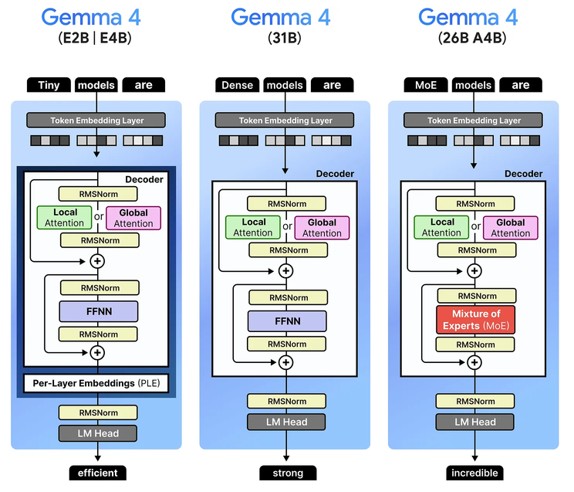

Gemma4 models/derivatives employed during this research.
Model | Context | Temperature | Set-seed | Parameters | Appears in Data
Gemma4:26b | Default (4-64k) | 6 | No | 26 billion | No
Gemma4-df | 32k | 0 | Yes | 26 billion | Yes
Gemma4-df-64k | 64k | 0 | Yes | 26 billion | No

Hardware/OS
Physical components of the machine this investigation was completed with, the machine LLMs hosted and run on.
Operating System | Kali GNU/Linux Rolling 2026.3
CPU | 13th Gen Intel(R) Core(TM) i5-13500
GPU1 | Nvidia GeForce RTX 3060
GPU2 | Nvidia GeForce RTX 3070
Memory (RAM) | 2x 8GB DDR5

Design Science Research
The team adapted the Design Science Research (DSR) methodology which places emphasis on the continuous improvement of “artefacts” to produce products of incrementally higher quality. This style of methodology benefited the team with the value of the team’s supporting technical advisor during this investigation. Artefacts such as human generated reports, LLM scripts, and data collection and presentation were continuously refined with expert input guiding the process. This methodology greatest leveraged this expert relationship to produce research and findings more in touch with real world professionals.
Figure 2 - Adapted DSR Methodology Diagram
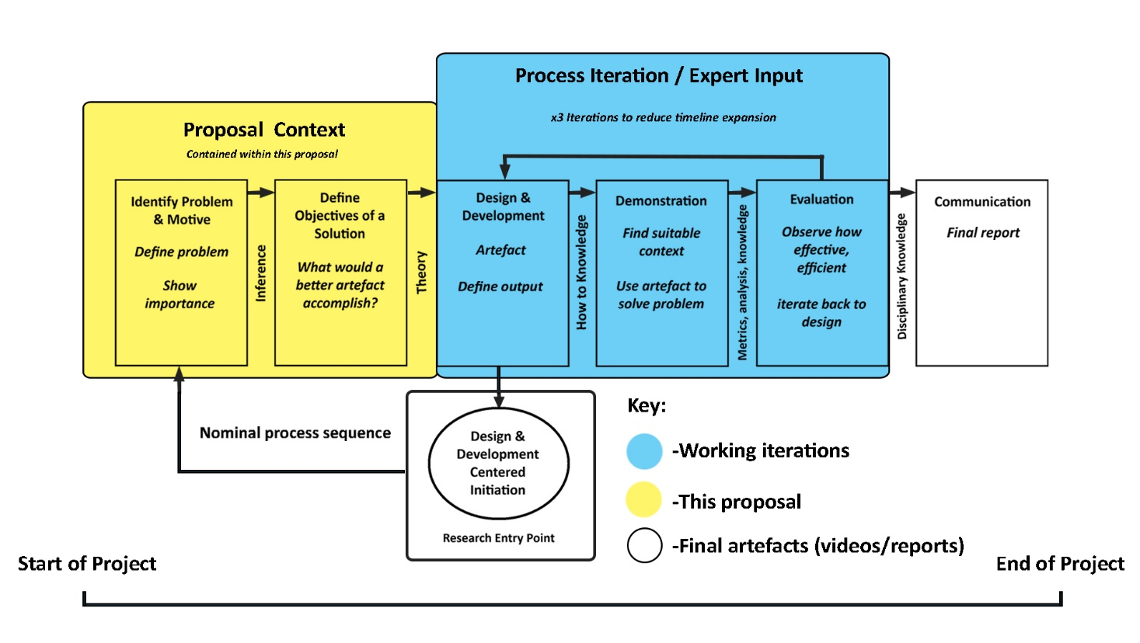

Findings

Context Problem
The most significant challenge identified in this research is unique to local deployments and reveals a problematic paradox. DFIR datasets can be massive in scale, yet the doctrine of secure analysis prescribes a necessity to command a significantly restrained available context length. This issue was addressed in this investigation by the reconfiguration and engineering of the local testing environment, model provision, and manipulation of input data. Tasks such as increasing the default Ollama context window to 32k, disabling thinking which counts towards output context, employing prompt chunking to leverage multiple prompt runs on one dataset, and reducing the token count of input data through conversion to those more consumable satisfied this end.
Experimental scripts that employ chunking of input data into 4 prompts, and the usage of an experimental 64k context model, applied to a 7442 packet pcap file, were observed to stretch out the available input context to above 134k.
Figure 3 - Experimental Script Execution Illustrating High Context Capacity
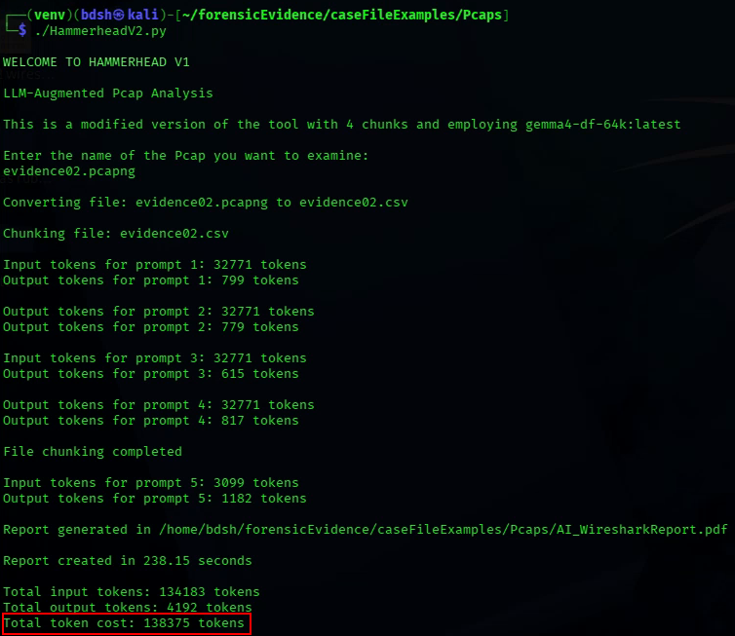

Input Data

Foremost
The nature of processing Foremost data with an Ollama-hosted LLM model presents some complications that are impossible to avoid. Foremost file carves produce a range of filetypes, ZIP, BMP, JPG, PNG, DOCX, PPTX, XLSX, PDF, and more, each being necessary to convert to plaintext that an LLM can read. Ollama prompts can only inspect one image at a time, so any scripted solution to analysing a foremost output directory would have to involve one prompt per image file. A human does not experience these challenges and can consume carved files as they appear in front of them.

Nmap
Nmap scans can be saved as either an XML or a raw human readable output. XML is considered a consumable format by LLMs owing to its comma separated nature, but because of the massive increase in syntactical clutter when outputting Nmap scans as XML The team observed those files to require far more context and therefore this file type becomes less ideal than the human readable output if token count is prioritized. Using .txt instead of .xml means that larger Nmap scans can be employed without requiring further context engineering.
The same Nmap service scan outputted as .xml and .txt. The xml has 163 lines to 83 for the .txt, 767 words to 468 for the .txt, and 46659 bytes to 3652 for the .txt:
Figure 4 Size Comparison of .txt and .xml Case Files
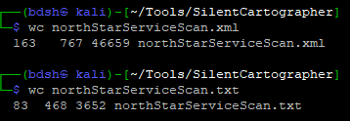

Wireshark
Wireshark presents the largest investigable datasets in the form of network packet captures. This data includes source/destination IP, frame numbers, and info column contents for every single network packet captured, in some datasets numbering in the tens of thousands. The impact of this was mitigated by exporting the Wireshark packet dissections that would be most relevant to an LLM analyst with “tshark” and feeding that data directly to an Ollama model as a CSV file. Ollama and Gemma4 still struggled greatly with the sheer size of input data despite 32k context capacity and prompt chunking, which was evident in the quality of the reports.

In this example below, the AI hallucinates the packet range it was explicitly asked for (1) and is unable to fully reassemble a message that appears from the subject typing one character at a time (2). The original message was “iknowyouarewatching” but it fails to identify this, likely due to the LLM having to keep in mind a large string of TCP packet data.
Figure 5 – LLM-Generated PCAP Report Containing Erroneous Data
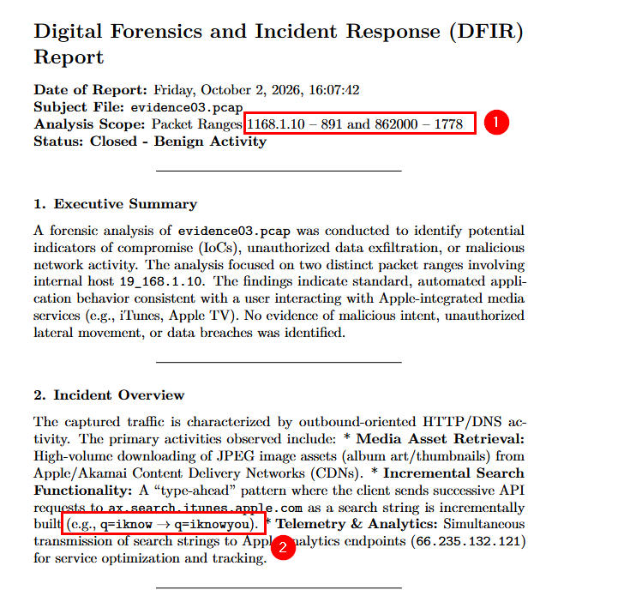

Generation Period
The LLMs took significantly less time to produce a report. Across all case file data (foremost output, nmap scans, packet captures) the team recorded a mean generation time of 50.75 seconds. The shortest generated report taking 21.06 seconds, the longest taking 83.52 seconds. The raw data supporting this finding can be found in Appendix A – Script Performance Data.
It is worth noting that though the execution times of the scripts is vastly shorter, these scripts took a mean time of 21.17 hours to develop. The shortest script took 13 hours, and the longest took 31.5 hours. With more sophisticated solutions development time is expected to be far greater. There is an investment of time to consider when deploying LLM automation locally. The team’s assessment is that the upfront time investment reduces the benefits LLM-augmentation has over human analysts in scenarios where only 1-3 reports need to be generated depending on the type of input data.

Figure 6 - Wireshark Break-Even Chart

Raw data with regards to time taken to generate LLM-augmentation scripts can be found in Appendix B – LLM-Script Generation Time on page 29.

Corrupted Input Data
Corrupted input data from fragmented disk images was investigated, in any LLM-augmented Foremost solution, images must be inspected with a vision model, the Ollama API must identify them as intact readable images first to allow the vision model to inspect them. The team found that partially corrupted images with remaining legible text will fail to pass to the LLM.

Test 1 - L0_Images.dd (no fragmentation)
The first case - this image is fully intact.
Figure 7 - 00056902.jpg, An Uncorrupted Image
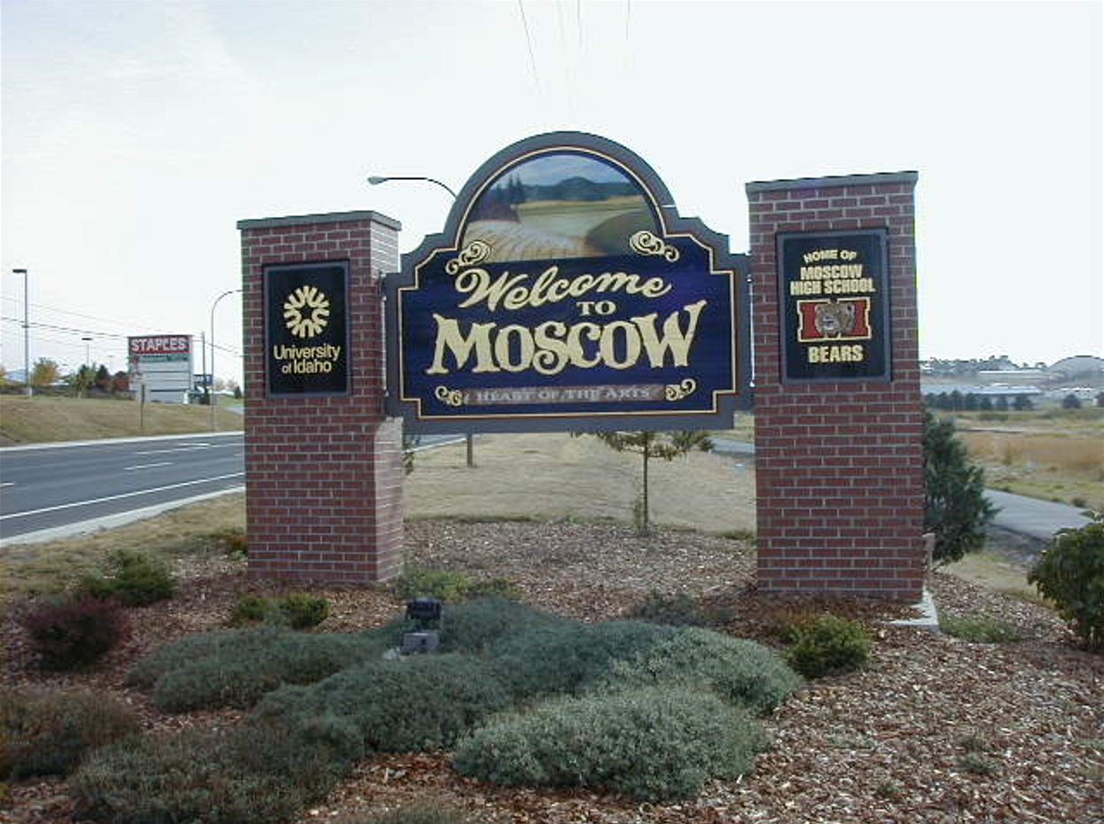
Ollama will pass through and allow a vision model to examine the image
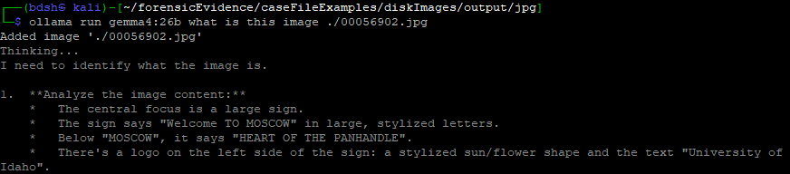

Test 2 – L3_Images.dd (missing fragments)
Traditional image viewing applications such as GIMP or Windows media viewer will let you view the corrupted image; a human examiner can still comprehend and extract information from the intact parts of this image.
Figure 8 - 00010000.jpg, A Partially Corrupted Image
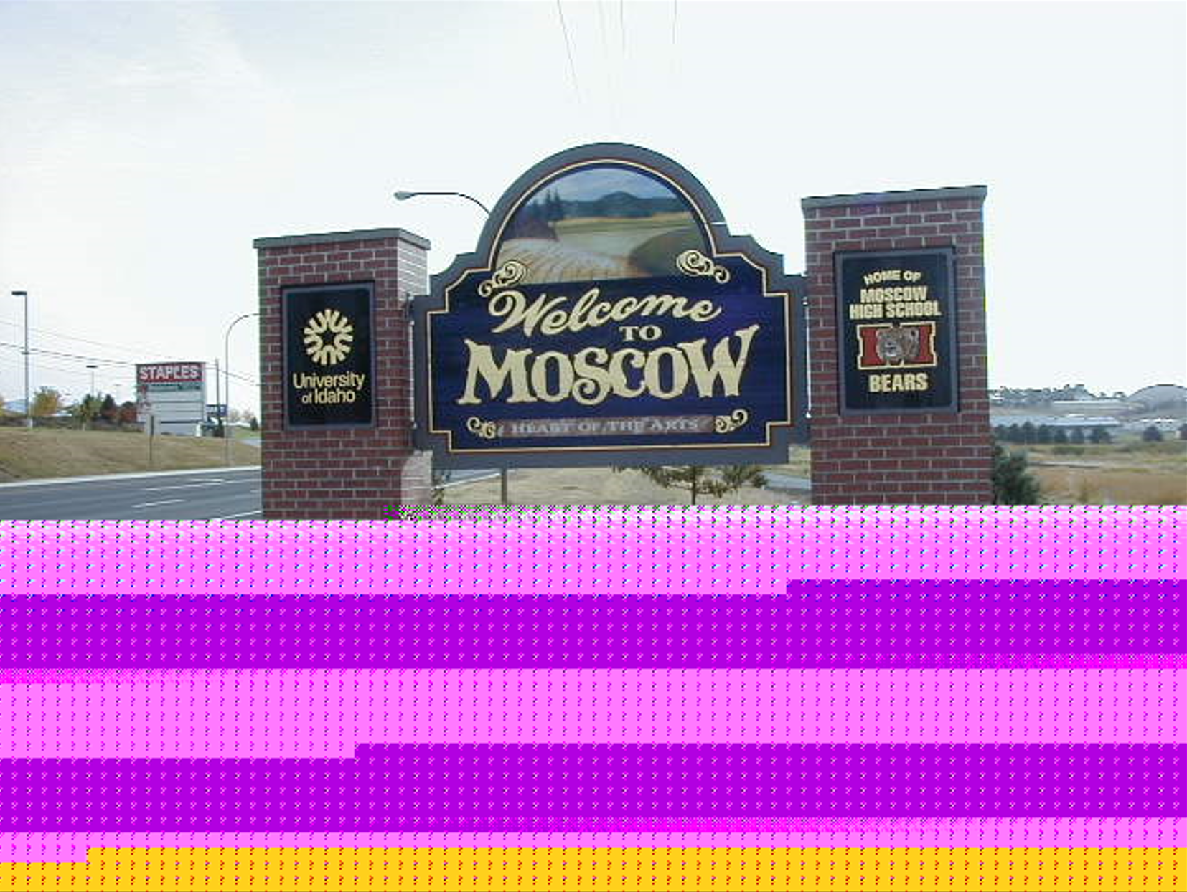
Ollama throws an error and does not pass the image.
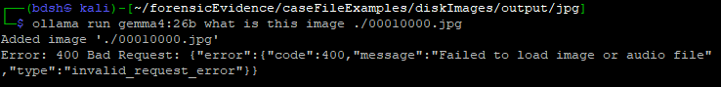

Thinking Enabled vs Disabled
“Thinking” is a parameter that can be configured on and off with Ollama prompts. Thinking enables an Ollama hosted LLM to attempt to “reason” through the input context to reach a more accurate answer (Ollama, 2025).
The team tested for observable differences between reports generated with thinking enabled and disabled.

LLM Misspelling
Although enabled thinking cannot be assigned unequivocally as the cause for the typo, it is worth hypothesising so. This is because “thinking” forces the LLM to look over the same data multiple times, multiple reprocesses increase the risk that data is corrupted/modified by hallucination, even with the low temperature configuration of the model the team is employing.
Figure 9 - Thinking AI Making a Typo
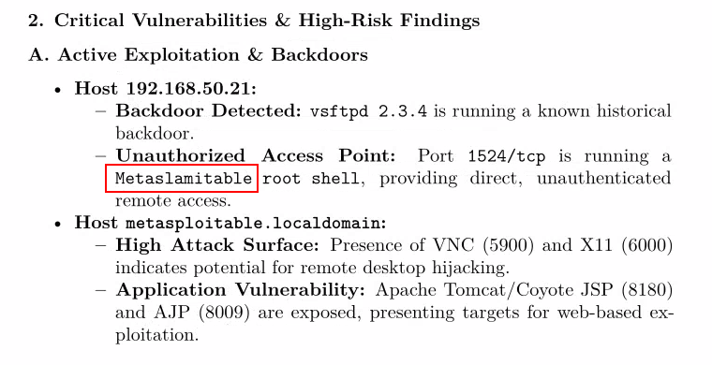

Erroneously Assigned Service Information
One extremely interesting finding is that all the reports generated with thinking disabled erroneously consider host .22 to have port 5900 (VNC service) and Apache Tomcat 8180 open (1, 2).
Figure 10 - Report Generated with Thinking Disabled
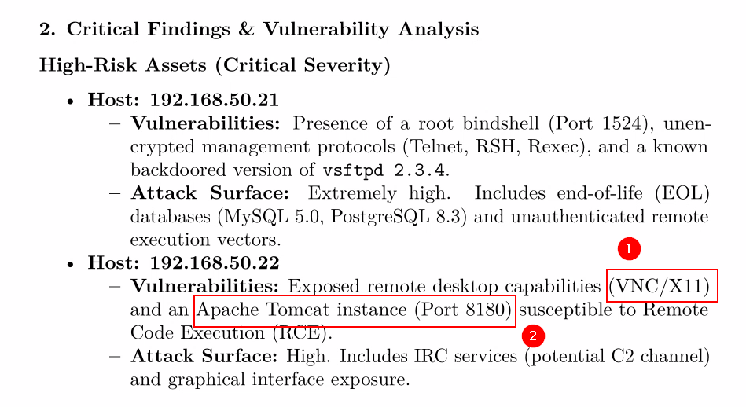
This is because the script prompt chunks by splitting this 82-line source scan in half (41-82 half highlighted). The scan for host .21 (metasploitable) (1) is cut off during this process (2). Because this data appears in the second chunk above host .22’s scan (5), it is associated with the orphaned service info (4), (5) by the LLM. Even though the raw data from the Nmap scan points to a different objective reality.
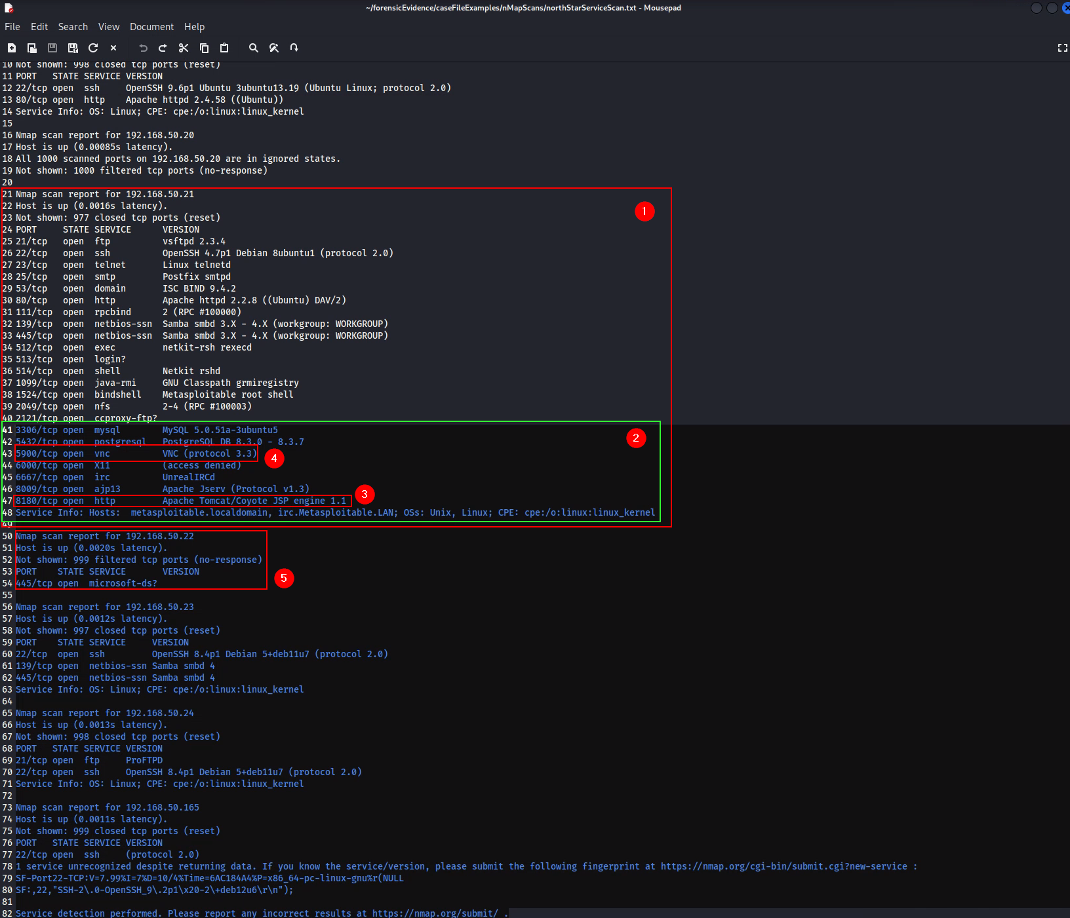

The script with thinking enabled on its prompts however can piece together and recontextualize the chunks more accurately. This is evident in all the reports generated. They are all able to assign the exposed services to the host that the original Nmap scan identified. This finding demonstrates a limitation when working with local LLMs on DFIR datasets, and a drawback to the prompt chunking solution.
Figure 11 – LLM Report Generated with Thinking Enabled
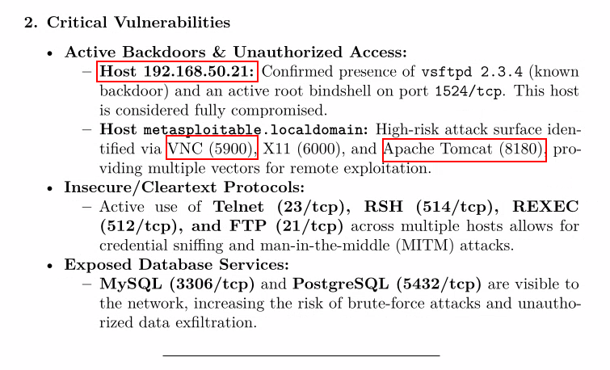

Performance
Effects on physical hardware were observed and monitored using Nvidia SMI during the execution of the team’s LLM-automation scripts. Metrics assessed are GPU temperature, power draw, and Video Random Access Memory (VRAM) usage across the duration of script execution with the targets being every case file. Complete metrics can be found in Appendix A – Script Performance Data.

Power
When running LLMs locally, and especially when using multiple GPUs, it is important to have an adequately high wattage PSU to compensate for large power draws.
Because of the requirement that the solution “file-chunks” the input data to distribute the token requirements for each engagement, three distinct prompt calls are made to the Gemma4-df model through Ollama. The first two prompts that summarize two halves of the input data are responsible for most of the hardware demand as they are accessing large quantities of raw data. The third prompt is simply accessing the concatenated output of the first two prompts and generating the final report. Figure 12 - Respective token usage for 3 prompts shows the relatively low context requirement of the latter prompt.
Figure 12 - Respective token usage for 3 prompts
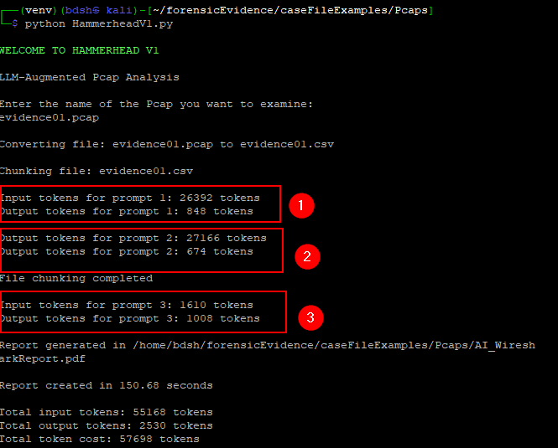

The respective drawing of resources between the three prompts correlates to sustained power draw observed on the GPUs. Figure 13- Power fluctuation on an RTX 3070 GPU during script execution clearly illustrates ~75 Watt loads sustained over a period of ~43 seconds for the two prompts with input context of ~27000 tokens, while the third prompt lasts only several seconds and draws 20% less power. With larger datasets that require more prompt chunking the expectation on a PSU would increase.
Figure 13- Power fluctuation on an RTX 3070 GPU during script execution
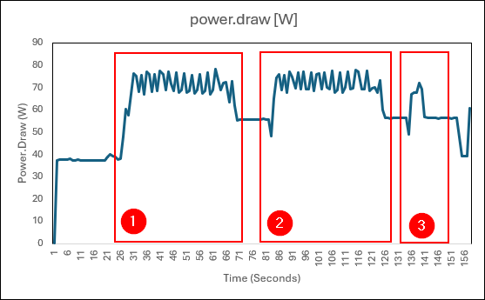

Temperature (Physical)
The same pattern is muted but nevertheless visible in the recorded core temperature of the GPUs under load. Because the peak temperature increases gradually as prompts are called, it is assumed that also if a larger forensic dataset is to be chunked that peak temperatures would rise even further. A 3070 will only start throttling performance at temperatures of 93 degrees. (NVIDIA, 2021) An operating temperature of 43 degrees is well within the safe operating temperature, especially for the short load durations that the team’s solutions demand of LLMs.
Figure 14 - Temperature fluctuation on an RTX 3070 GPU during script execution
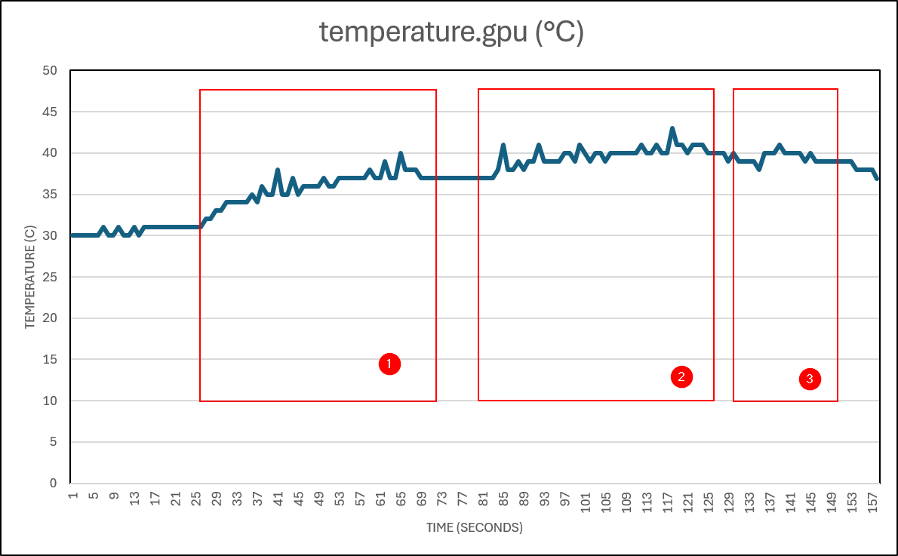

Memory
Per-prompt memory usage remains static throughout the entire script execution.
Figure 15 - Memory usage on an RTX 3070 GPU during script execution

Accountability/Traceability
A severe epistemological challenge with employing LLMs to scrutinize and produce actionable, verifiable, and reliable findings, especially in professional settings, is that the source of their findings, and the way they came to those conclusions is obscured by the nature of their complexity. The team found that reports generated for Nmap were able to trace and track what host and what service their findings come from, which could be cross-referenced with the raw data it was asked to inspect. However often with larger datasets especially PCAPs the LLMs interest in avoiding informational redundancy would only display an incomprehensive example of a finding.

Non-comprehensive indications
The LLM reports generated were found to avoid enumerating the full truth of a situation, instead selecting a single example to represent the entire finding. This is most evident in reports that inspect pcap data. Information like this could misinform network engineers or investigators relying on the AI report as these incomplete misrepresentations undermine the scale of an attack on a network’s availability. Figure 16 - Incomplete Packet Loss Data demonstrates where the LLM has failed in telling full truth by not providing a comprehensive enumeration of data such as the other network congestion that is visible in the raw data, such as those seen in Figure 17 - Duplicate ACKs and Spurious Retransmissions that Indicate Packet Loss. The human generated report demonstrated a full identification of 3 packet loss zones specifically in the transmission of packets in Evidence02.pcapng. This is identifiable in Figure 18 - Human Generated Report on Evidence02 with Mention of All Packet Loss Instances. Although this report overall is lacking the quantity of findings the LLM produced overall. No matter the input data and number of possible findings, the LLM outputs we observed will always attempt to make a report of a seemingly predetermined length. It is also observed that LLMs findings appear “forced” to that end.
Figure 16 - Incomplete Packet Loss Data
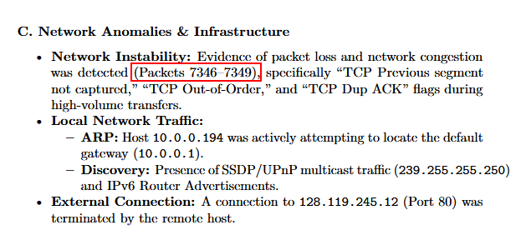
Figure 17 - Duplicate ACKs and Spurious Retransmissions that Indicate Packet Loss
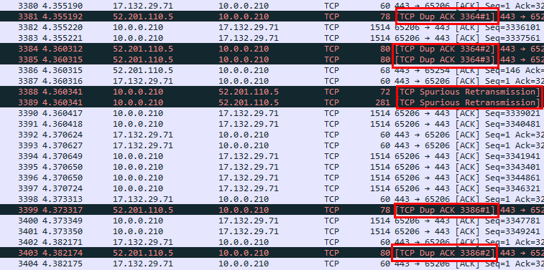
Figure 18 - Human Generated Report on Evidence02 with Mention of All Packet Loss Instances
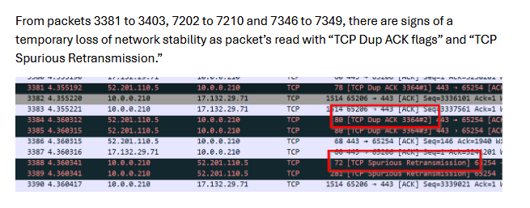

Conclusion
In conclusion, LLM-generated DFIR report outputs can provide quick, actionable summaries and recommendations that could most realistically support a human investigation in its initial stages.
In contexts such as Incident Response (IR) that value swift triage and identification of intrusion indicators this use case is most effective. Ollama is unreliable in feeding LLMs corrupt image data from Foremost output. Lack of complete enumeration, and risks of incomplete, erroneous, or misleading data, means that in Digital Forensics (DF) contexts which value integrity, traceability, and accuracy, LLM generated outputs require an intense amount of validation by a real expert to be actionable and are thus limited in usefulness.
The risks of these limitations increase when simple prompt chunking is employed. This research found that it is realistic to provision and deploy a local LLM-enhanced DFIR solution in small business to enterprise scale environments. Running a single dedicated host with 2 mid-range GPUs can support context windows of well above 130k tokens. The initial time investment to develop proprietary tools like those demonstrated in this report presents an ultimately inconsequential challenge when met with that LLM-augmented tool’s capacity to eclipse the report generation time offered by human analysts on average.

Recommendations

Input Data

XML
The team would recommend that XML format be avoided as an input for local LLMs to produce reports based on Nmap output. Although XML is an output format supported natively as an output by Nmap, and XML is a structure that is highly consumable by AI, .txt overall presents a lower input token count while producing reports of an identical quality.

CSV
The team recommends exporting pcap packet dissections as a CSV file, this is because LLMs find structured data formats like CSV very consumable, the size of a pcap after processing can be reduced significantly. Parsing pcaps with “tshark” also allows a great deal of configuration as you can select exactly what fields from packet dissections you want the LLM to inspect.

Case File/Format | Lines | Words | Bytes
evidence01.pcap | 3920 | 6011 | 335144
evidence01.csv | 572 | 7928 | 56157

Figure 19 - Size of Data in PCAP and CSV Formats Respectively
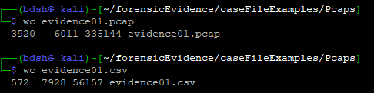

Configuration
If employing a similar prompt chunking solution, keep thinking on. This reduces the risk of critically erroneous findings being generated by the LLM when inspecting scattered input data.
Increase the context window override to as large as possible depending on your hardware.
Use the Gemma4:26b LLM model or a derivative. It provides the best performance and quality of output of any local model tested.

For Future Research
We hypothesise based on our research that you could theoretically do a larger scale number of prompt chunks on larger datasets. With the relatively short durations our LLMs took to produce
We recommend future researchers look at developing solutions that dynamically increase the number of chunks a script splits input data into based on the size of input data. Tweaking this mechanism would require more script engineering than our team had time for.
For Foremost-produced data especially, further investigation into corrupted content would be valuable, this presents a point where differences lie in how humans and LLMs may interpret the information they are given.
Pick a single tool to augment with LLMs. Selecting multiple tools made it difficult to define universally desirable properties of reports. It also focuses the effort of the script developer.
Investigate a hybridised testing scheme. The scripts developed in service of this research were too unsophisticated, and the context of input data was too large to produce reports that come to strong, traceable resolutions. The team would be interested in how human testers would perform and rate the usefulness of following threads generated by the limited analysis provided by LLMs.
The LLM-generated Foremost reports could be expanded to include inspection of every file. In the current script, the LLM is only reporting on the output.txt. Visual LLM models can analyse and give descriptions of images, so a solution could be developed that inspects every file/image consecutively. This was a stretch goal our team were unable to fulfil in time.
Some findings may be products of limited context windows, rather than products of the fallibility of LLMs themselves. Further research is required that takes advantage of greater context length to be sure.

Data Collection / Analysis and Visualization
Reproducing the GPU hardware performance data collected would require the use of the same command that we used which was “nvidia-smi --query-gpu=name,memory.used,temperature.gpu,power.draw --format=csv -l 1 >> gpu_usage.csv” this command uses Nvidia-Smi to query the GPU/s every second, collect their details and append them into a CSV file. This was run against every case file three times before the data was then converted from CSV to XLSX, cleaned, organized, averaged then graphs were generated using headers from each column (i.e. Memory. Used). If one is to revisit this investigation this is how we recorded the hardware performance metrics for AI scripting.

References
Grootendorst, M. (2026, April 4). A Visual Guide to Gemma 4. Retrieved from newsletter: https://newsletter.maartengrootendorst.com/p/a-visual-guide-to-gemma-4
NVIDIA. (2021). GeForce RTX 3070 Family. Retrieved from Nvidia: https://www.nvidia.com/en-us/geforce/graphics-cards/30-series/rtx-3070-3070ti/
NVIDIA. (n.d.). Mixture of Experts. Retrieved from NVIDIA: https://www.nvidia.com/en-us/glossary/mixture-of-experts/
Ollama. (2025, May 30). Thinking. Retrieved from Ollama: https://ollama.com/blog/thinking

Appendices

Appendix A – Script Performance Data
GPU 1 = Nvidia GeForce RTX 3060, GPU 2 = Nvidia GeForce RTX 3070
Performance data was recorded across script execution duration 3 times per case file. Scripts used had thinking disabled, with 32k context available.
Foremost LLM Augmentation
Metrics gathered during LLM report generation for Foremost data (disk images). All figures are averages (mean). The foremost solution had no prompt chunking.
Input Data | Time | Input Tokens | Output Tokens | Total Tokens | GPU 1 VRAM (MiB) | GPU 2 VRAM (MiB) | GPU 1 Power (W) | GPU 2 Power (W) | GPU 1 Temp (°C) | GPU 2 Temp  (°C)
EIGHT.dd | 38.86 | 2020 | 756.67 | 2776.67 | 8448.00 | 7064.00 | 97.84 | 50.48 | 41.03 | 30.02
Three.dd | 22.70 | 911 | 897.33 | 1808.33 | 7609 | 6322 | 87.37 | 48.01 | 37.32 | 30.23
NINE.dd | 21.06 | 2020 | 758 | 2778 | 7362 | 6109.30 | 84.80 | 50.00 | 39.58 | 33.84

Nmap LLM Augmentation
Input Data | Time (avg) | Input Tokens | Output Tokens | Total Tokens | GPU 1 VRAM (MiB) | GPU 2 VRAM (MiB) | GPU 1 Power (W) | GPU 2 Power (W) | GPU 1 Temp  (°C) | GPU 2 Temp  (°C)
Nmap_example.xml | 66.62 | 21715.67 | 2726.33 | 24441 | 8062 | 6724.83 | 92.27 | 50.29 | 41.50 | 31.17
SOITnetworkscan.xml | 48.59 | 17436 | 2254 | 19684 | 8449 | 7065 | 75.70 | 41.83 | 42.46 | 30.00
28sepServiceScan.xml | 55.06 | 32149 | 2235.33 | 34384.33 | 8450 | 7066 | 80.69 | 44.99 | 44.94 | 32.23
Metrics gathered during LLM report generation for Nmap data (Nmap scans). All figures are averages (mean).

Wireshark LLM Augmentation
This table records metrics gathered during LLM report generation for Wireshark data (packet captures). All figures are averages (mean).
Input Data | Time (s) | Input Tokens | Output Tokens | Total Tokens | GPU 1 VRAM (MiB) | GPU 2 VRAM (MiB) | GPU 1 Power (W) | GPU 2 Power (W) | GPU 1 Temp (°C) | GPU 2 Temp  (°C)
evidence01.pcap | 83.52 | 55216.33 | 2650.67 | 57867 | 8098.93 | 6759.02 | 93.00 | 51.89 | 45.60 | 33.83
evidence02.pcapng | 60.94 | 33661.33 | 2498.67 | 36160 | 8448 | 7064 | 81.88 | 45.33 | 45.28 | 33.23
evidence03.pcap | 60.40 | 33687.33 | 2476 | 36163.33 | 8449.30 | 7065.30 | 66.78 | 38.64 | 43.86 | 32.79

Appendix B – LLM-Script Generation Time
Script | Development Time
NinemostV1 | 31.5 hours
SilentCartographerV1 | 19 hours
HammerheadV1 | 13 hours
Average (mean) | 21.17 hours

